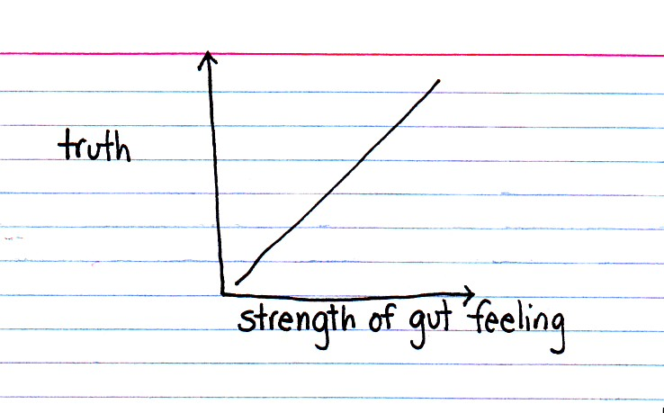
IV. WHERE IT ALL WENT WRONG (GENESIS 3).

John Davis: "It would have been marvelous indeed if the same could be said of man throughout history that was said in the beginning: he was 'not ashamed' (2:25). The Edenic paradise represented God's best for man; He had anticipated every human need and circumstance, and made adequate provision for it. All that God had created was good, and man enjoyed the closest, most intimate relationship with Him. How tragic that in Genesis 3 man's relationship with God was spoiled and the course of human history drastically altered."

Even though Adam and Eve enjoyed a perfect relationship with God in the Garden of Eden, things would not remain perfect for long. We saw in Genesis 2 that in this perfect relationship, man remained dependent upon the Lord's instructions and commands. In that sinless environment and before the fall, the first man and woman needed God's counsel to understand why they had been created and placed in the garden. Perfection did not suggest that they were independent to determine their purpose for themselves. As long as they listened to the counsel of God, they would enjoy a good and perfect life with their Creator.
But when the serpent came along to tempt Eve, this perfect relationship was challenged. With those words, "Did God actually say?" seeds of doubt were implanted in the mind of the woman. Unfortunately, Adam and Eve decided not to listen to the counsel of God, but to the counsel of the serpent instead. By his cunning in causing Eve to doubt the words of God, the woman was deceived and fell into sin. Not much later, she gave the forbidden fruit to her husband Adam, and he ate as well. By their disobedience to the command of God, sin entered into the world and the world suffered the consequences for their sin.

Paul David Tripp: "God knew that even though Adam and Eve were perfect people living in perfect relationship with him, they could not figure out life on their own. They were created to be dependent. God had to explain who they were and what they were to do with their lives. They did not need this help because they were sinners. They needed help because they were human."

1. Satan used the serpent in Genesis 3 to tempt Eve. Though Satan is not named directly in the passage, it is clear from Scripture that he is behind the temptation (Rev. 12:9; 20:2; cf. John 8:44; 1 John 3:8). The passage describes the serpent as crafty (Heb. arum; cf. Eph. 6:11).

a. Look up the following passages and write down what other descriptions the Bible gives Satan.

John 8:44

1 Peter 5:8

Revelation 12:9
b. What are some of the names given to Satan in Scripture?

Matthew 4:3

Matthew 12:24

John 8:44

John 12:31

John 17:15

2 Corinthians 4:4

Revelation 9:11

Revelation 12:10

The Problem of Evil

When reading the biblical account of the fall of man, it is inevitable that someone will ask, "Why did God allow these things to happen? Why didn't He make it so that sin never existed and evil never came into the world?" The problem of evil is understood by some to be the most difficult of problems for Christians to explain. David Hume described it succinctly, "Is [God] willing to prevent evil, but not able? then he is impotent. Is he able, but not willing? then he is malevolent. Is he both able and willing? whence then is evil?" The Bible gives a sufficient solution to the problem of evil, and it does so while upholding God's goodness and sovereignty, man's freedom (i.e., man is not a robot without the ability to make choices), and God's holiness and love.

1. God is absolutely sovereign over all things including the evil that exists (Exod. 4:11; Job 1:21; 2:10; 12:7-10; Prov. 15:3).

2. God is perfectly good in all that He is and does (1 Chron. 16:34; Ps. 25:8; 34:8; cf. James 1:13, 17).

3. Evil truly exists (Job 1-2; Gen. 6:5; 8:21; Ps. 34:13-14; 3 John 1:11).

4. God has a morally good and sovereign plan that He works out by His eternal power that includes the existence of evil (Gen. 50:20; John 9:2-3; Rom. 11:30-36).

The problem is not that the Christian cannot explain the existence of evil in light of the existence of a good and sovereign God. The problem is that the unbeliever chooses to reject the biblical solution. The unbeliever reasons, "Certainly a good God would not permit the existence of evil!" but that is a huge assumption. Through the existence of evil:

1. God is able to demonstrate His glory through His perfect character. He not only shows His love to men by sending His Son Jesus Christ to be the Savior of the world (John 3:16; Rom. 5:8), but He also demonstrates His righteousness and justice through his judgment of evil (cf. Rom. 3:25-26).

2. God proves His persevering love and the security of believers in that nothing can separate the believer from the love of Christ (Rom. 8:31-39).

3. Men are grown into greater Christ-likeness through perseverance in trials (2 Cor. 4:6-12).

4. God receives greater glory in the end (Ps. 79:9; 115:1; Isa. 48:9-11; Rom. 11:36).

Lewis Chafer writes, “In conclusion, it must be said that God’s primary divine purpose was not to avoid the presence of sin. He could have prevented it if He had willed to do so. To achieve His purposes, which were holy, just, and good, God had to permit sin in order to demonstrate His glory – especially His righteousness, love, and grace.”
Consider these principles for application in light of the solution to the problem of evil:

1. Rather than focusing on the things we do not know, it is better to focus on the clear truths of Scripture that we do know. We may not be given the reasons for our suffering (cf. Job), but we do know confidently that there is a good, kind, sovereign God working behind the troubles we face.

2. People need to be careful not to elevate themselves to the place of God in demanding answers. God says in Romans 9 that He will have mercy on whom He will have mercy. We need to humbly recognize that we are the clay and He is the potter (Isa. 29:16; 64:8; Rom. 9:21).

3. It is tremendously comforting to know that regardless of how difficult a situation a person finds himself in, God is in control. He knows how to help in every situation and is able to deliver from the most trying circumstances.

2. Compare God's direct command to Adam in Genesis 2:16-17 and Eve's account in Genesis 3:2-3. What changes do you see in Eve's adaptation of the command?

God's Command (Gen. 2:16-17):

[16] And the LORD God commanded the man, saying, "You may surely eat of every tree of the

garden,

[17] but of the tree of the knowledge of good and evil you shall not eat, for in the day that you

eat of it you shall surely die."
Eve's Account (Gen. 3:2-3):

[2] And the woman said to the serpent, "We may eat of the fruit of the trees in the garden,

[3] but God said, 'You shall not eat of the fruit of the tree that is in the midst of the garden,

neither shall you touch it, lest you die.'"

John Davis: "Did Eve know that she was being tempted? Since this was the first temptation, how could she have understood that her very relationship with God was being threatened? Eve was, according to the New Testament, deceived, but she was not totally naïve. She knew well the goodness and care of God, whose beautiful creation surrounded her. She and Adam undoubtedly communed with God and recognized the glory of His presence. Certainly Eve recognized that snakes do not speak, knowing that man alone is capable of rational judgment and communication. But the animal's question was so enticing that she overlooked the unnaturalness of the situation. The result was the most disastrous dialogue in the history of the human race."

3. Satan's tactic has always been to cause men to question, doubt, disbelieve, and challenge God's truth. What does each of these following passages teach about Satan's schemes?

Matthew 13:19

John 8:44

2 Corinthians 4:4

4. What was the serpent's response to Eve (vv. 4-5)? What was he specifically challenging from God's command?

5. Describe in your own words the events that led to Eve's sin? What was going on in her mind when she fell into sin (v. 6)?

a. How does this verse compare to 1 John 2:16?

b. What does the text imply when it says that Eve saw "that the tree was to be desired to make one wise"?

"Grace Greater Than Our Sin"

Marvelous grace of our loving Lord,
Grace that exceeds our sin and our guilt!
Yonder on Calvary's mount outpoured –
There where the blood of the Lamb was spilt.

Grace, grace, God's grace,
Grace that will pardon and cleanse within
Grace, grace, God's grace,
Grace that is greater than all our sin!

Sin and despair, like the sea waves cold,
Threaten the soul with infinite loss;
Grace that is greater – yes, grace untold –
Points to the refuge, the mighty cross.

Dark is the stain that we cannot hide –
What can avail to wash it away?
Look! there is flowing a crimson tide –
Whiter than snow you may be today.

Marvelous, infinite, matchless grace,
Freely bestowed on all who believe!
You that are longing to see His face,
Will you this moment His grace receive?

Thoughts for Application:

1. Proverbs teaches, "the fear of the Lord is the beginning of wisdom" (Prov. 9:10a). Whose wisdom should they have listened to? Whose wisdom did they trust in the end?

2. How did Satan get Eve to doubt the command of God? What exactly did he cause Eve to doubt?

3. How would you seek to explain the problem of evil to a child?

4. How does Satan continue to use similar methods to tempt people to sin today (cf. 1 John 2:16)?

5. How do people continue to fall to sin in the same way that Eve fell in Genesis 3? In what ways do people continue to trust in deceptive wisdom outside of God's truth?

John J. Davis, Paradise to Prison: Studies in Genesis (Salem, Wisc.: Sheffield Publishing Company, 1975), 85.
Paul David Tripp, Instruments in the Redeemer's Hands (Phillipsburg, N. J.: P&R Publishing, 2002), 40.
Greg L. Bahnsen, Always Ready, ed. Robert R. Booth (Nacogdoches, Tex.: Covenant Media Foundation, 1996), 166.
Lewis Sperry Chafer, Systematic Theology, abr. ed., eds. John F. Walvoord, Donald K. Campbell, and Roy B. Zuck (Wheaton, Ill.: Victor Books, 1988), 1:158.
Davis, Paradise to Prison, 88-89.

