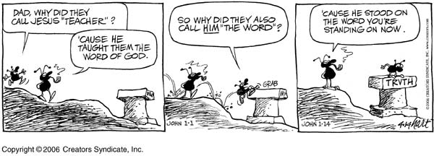
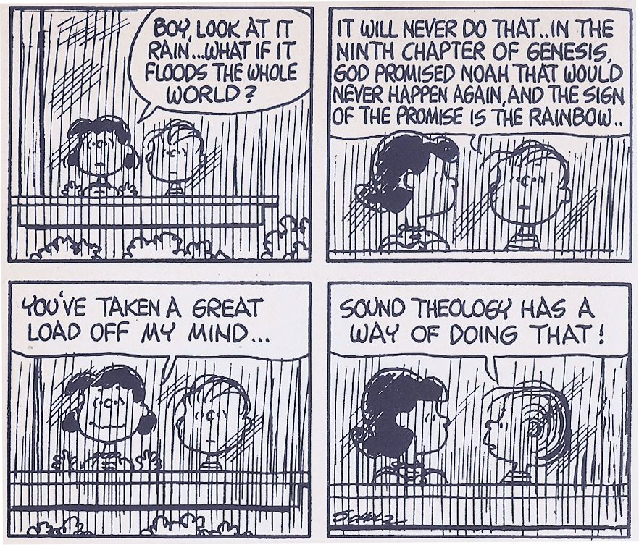
IX. The Truth, the Whole Truth, and Nothing But the Truth.

¹¹ Teach me your way, O LORD, that I may walk in your truth; unite my heart to fear your name. – Psalm 86:11

By God's grace, through the Bible we are given divine revelation to lead us in the truth and in life. Though God reveals Himself through creation in general, the special revelation of His Word gives us specific details about who He is, what He is like, why He made us, and what He requires of us. The idea of the inspiration of Scripture means that the Bible was "breathed out" by God (Gr. theopneustos; 2 Tim. 3:16). This inspiration was verbal in that the words themselves were given by God. God did not inspire the human authors like Michelangelo was inspired to paint the Sistine Chapel. God specifically inspired the writings.
The inspiration of Scripture was plenary in that all parts of the Bible are equally inspired. There is not one section of Scripture that is more divine or more inspired than another. All of it is equally inspired by God and true (cf. Matt. 5:18). Whether it is Jesus speaking in the Gospel accounts or Paul writing to the Thessalonians or Moses giving an account of the genealogy of Cain, all Scripture is God-breathed and profitable for teaching, reproof, correction, and training in righteousness.
God worked through human authors to pen the Bible. As you read the pages of Scripture, you can get a sense of their various backgrounds, writing styles, unique vocabulary, and personalities. However, what they wrote was not merely human thoughts or worldly wisdom. The Spirit of God guided them to write perfect truth (2 Pet. 1:20-21).
A couple things are derived from our understanding of Scripture's inspiration. First, because the source of the Bible is God, we can be sure that the Bible is inerrant (without errors). Since God is the God of truth and His Spirit of truth superintended the writing of Scripture, we can be sure that the Word is truth (John 17:17). When God had the authors pen His Word, He kept the original manuscripts perfect and free from error. Any subsequent copies or translations of the Bible are equally inerrant insofar as they represent the original writings.

Paul Feinberg: “Inerrancy means that when all facts are known, the Scriptures in their original autographs and properly interpreted will be shown to be wholly true in everything that they affirm, whether that has to do with doctrine or morality or with social, physical, or life sciences.”

The second thing that is derived from God's inspiration of Scripture is that the Bible is authoritative. Since the words of the Bible are God's Words, they should be read and understood with the authority of the Lord behind them. The prophets often spoke, "Thus says the Lord," and so can we as we read the Bible. Paul was so confident of God's authority in Scripture that he could state, "We have the mind of Christ" (1 Cor. 2:16).

1. How would you define inerrancy in your own words? What do the following passages say about the truthfulness of Scripture?

a. John 17:17.

b. Psalm 119:160.

c. 2 Timothy 2:15.

d. 2 Peter 1:19.

2. It is significant to examine how people in the Bible treated and understood other passages of Scripture. Sometimes they appealed to the minutia of the text to make their point. This argumentation would be indefensible if the Scriptures were not inerrant. Consider the following passages. What is being communicated in these passages?

a. What is Jesus' point in Matthew 22:23-33 when He refers to Exodus 3:6? On what does the correct interpretation depend?

b. From Matthew 22:41-46, what is significant about the reference to the Messiah in Psalm 110:1? On what does the correct interpretation depend?

c. What point is Paul trying to communicate in Galatians 3:16? On what does the correct interpretation depend?

3. Read the following quotation. Though copies and translations of the Bible may contain errors, why should Christians today have great confidence that the Bible they hold is the Word of God?
Louis Berkhoff: “If we bear in mind that there are more than 4000 Greek MSS. of the New Testament, and in addition to that 6000 MSS. of the Vulgate, and 1000 of other Latin translations, then we understand that it was practically impossible that Scripture should be lost to the world for centuries, just as many of the writings of the Church Fathers were. Then we also understand what Kenyon, an eminent authority on the subject, says, ‘The number of manuscripts of the New Testament, of early translations from it, and of quotations from it in the oldest writers of the Church is so large, that it is practically certain that the true reading of every doubtful passage is preserved in some one or other of these ancient authorities. This can be said of no other ancient book in the world.’”

4. There are some who argue that while the Bible can be completely trusted in areas of spiritual instruction, it is not completely accurate when speaking about social, physical, and life sciences. What seems to be the problem in the following passages? How might you explain these passages while maintaining the inerrancy of Scripture?

a. Genesis 2:7.

b. Leviticus 11:13-19.

c. Ecclesiastes 1:5.

Clarification about Inerrancy

1. Inerrancy does not guarantee that all individuals will come to the same conclusions about every passage of Scripture. Inerrancy simply provides that the Scriptures are trustworthy, but men still have the responsibility of handling the Word of Truth with accuracy (2 Tim. 2:15). Proper biblical hermeneutics must be applied to come to correct interpretations of Scripture.

2. Inerrancy is a doctrine that cannot necessarily be proven with all the data of Scripture. Almost all of the historical claims of the Old Testament have already passed without any way of knowing how accurate those claims are (e.g. the size of armies, the speed of victories, etc.).

Paul Feinberg: “There are really only two choices: either the theologian will trust the word of an omnipotent, omniscient God, who says that He controlled human agents, making it necessary for the theologian to admit his fallibility as critic, or in some sense he will declare that the aforementioned control is restricted and will affirm at least his own relative and finite omniscience as critic. Since Christ exhibited total trust in the Scriptures, can we do less?”

3. Inerrancy applies to every part of Scripture as originally written (autographa). It does not apply to copies of Scripture except by derived inspiration.
a. Although copies and translations may contain errors due to transmission, this does not discredit the inerrancy of the Bible.

b. Because the process of textual criticism is generally reliable and the ancient texts of the Bible are able to be studied, inerrancy is still a viable doctrine even though we no longer possess the autographs.

c. Philip Schaff: “Only about 400 of the 100,000 or 150,000 variations materially affect the sense. Of these, again, not more than about 50 are really important for some reason or other; and even of these 50 not 1 affects an article of faith or a precept of duty which is not abundantly sustained by other and undoubted passages, or by the whole tenor of Scripture teaching.”

d. Wayne Grudem: “. . . it may first be stated that for over 99 percent of the words of the Bible, we know what the original manuscript said. Even for many of the verses where there are textual variants (that is, different words in different ancient copies of the same verse), the correct decision is often quite clear, and there are really very few places where the textual variant is both difficult to evaluate and significant in determining meaning. In the small percentage of cases where there is significant uncertainty about what the original text said, the general sense of the sentence is usually quite clear from the context. . . . This is not to say that the study of textual variants is unimportant, but it is to say that the study of textual variants has not left us in confusion about what the original manuscripts said. It has rather brought us extremely close to the content of those original manuscripts. For most practical purposes, then, the current published scholarly texts of the Hebrew Old Testament and Greek New Testament are the same as the original manuscripts.”

e. Aside from the fact that we are certain of about 99 percent of the text we have today, we know where the problem passages of the other 1 percent are.

4. Inerrancy does not mean the authors of Scripture could not use figures of speech (e.g. David saying, “I am a worm”). The text should be understood in its normal, everyday usage. The writers of the Bible used literary devices such as hyperbole (Matt. 2:3 – “and all Jerusalem with him”), personification (And the Scripture, foreseeing . . .” – Gal. 3:8), and synecdoche (“flesh and blood” – Gal. 1:16 [NAU]).

5. Inerrancy does not demand that the technical language of modern science be used. The Bible speaks of the sun rising and setting, but is not arguing for geocentricism. It categorizes bats with birds, but this should simply be understood as flying animals without respect to specific animal classes.

6. Inerrancy does not demand complete historical precision without the use of rounding off numbers (cf. 1 Chron. 5:21). This is part of what it means to use common language.

7. Inerrancy does not demand that the New Testament’s use of the Old Testament requires word for word quotation. Sometimes the New Testament writer summarized the text of the Old Testament.

8. Inerrancy does not demand that we have all the details about every account given in Scripture (cf. John 21:25).

5. How would you define the authority of Scripture in your own words? How do you know the Bible is authoritative?

6. How would you explain and defend the authority of God (Rom. 13:1)? How does Genesis 1 establish God's authority?

7. If the Bible is God's Word, and God is the ultimate authority, what can we conclude about the authority of the Bible?

"Wonderful Words of Life"

Sing them over again to me,
Wonderful words of Life;
Let me more of their beauty see,
Wonderful words of Life.
Words of life and beauty,
Teach me faith and duty;

Beautiful words, wonderful words, Wonderful words of life.
Beautiful words, wonderful words, Wonderful words of life.

Christ, the blessed One, gives to all
Wonderful words of Life;
Sinner, list to the loving call,
Wonderful words of Life.
All so freely given,
Wooing us to Heaven:

Sweetly echo the gospel call,
Wonderful words of Life;
Offer pardon and peace to all,
Wonderful words of Life.
Jesus, only Savior,
Sanctify forever:

Thoughts for Application:

1. If it was absolutely confirmed that the Bible affirmed minor errors, how would this affect the way you read or trust the Bible in general?

2. Who in your life would want you to doubt the truth of the Bible? What sorts of issues do they bring up in discussion? How do you respond to their objections?

3. Do you think it is important for a church's leadership to consistently uphold and defend the inerrancy of Scripture? Would it be ok for someone to serve on leadership that denied inerrancy?

4. Why is it problematic for someone to claim they believe in the inspiration of Scripture but not live by its principles?

5. As you have grown in faith, has your confidence in Scripture increased or diminished? Why do you think this is?

Paul Feinberg, “The Meaning of Inerrancy,” in Inerrancy, ed. Norman Geisler [Grand Rapids: Academie Books, 1980], 294.
Louis Berkhoff, “Introductory Volume to Systematic Theology,” in Systematic Theology: New Combined Edition (Grand Rapids: Wm. B. Eerdmans, 1996), 159.
Paul Feinberg, “Inerrancy,” 294.
Philip Schaff, A Companion to the Greek Testament and the English Version (New York: Harper and Brothers, 1883), 177.
Grudem, Systematic Theology, 96.

