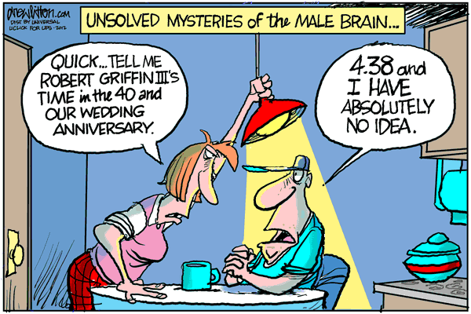
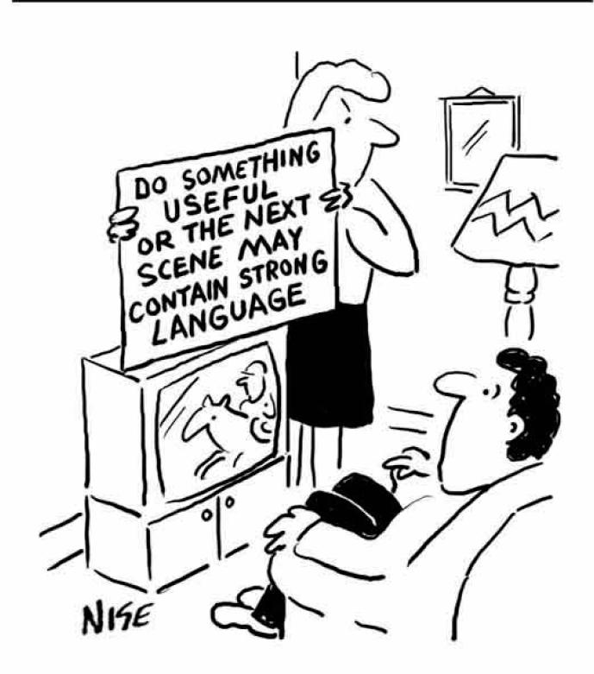
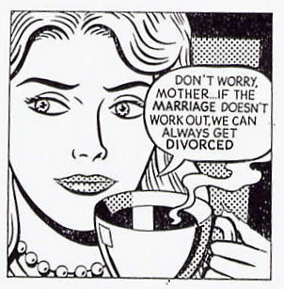
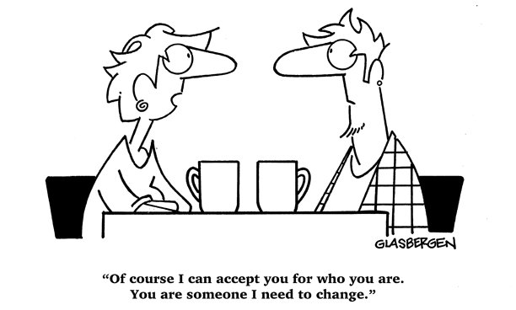
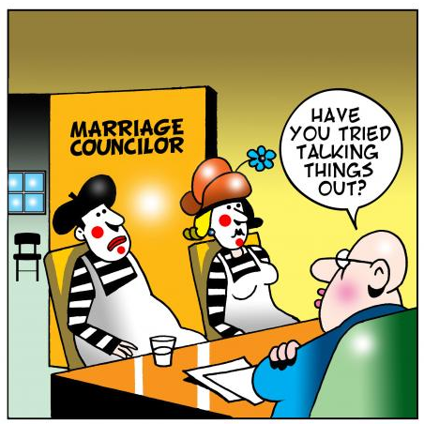
XI. Marriage God's Way.

²² Wives, submit to your own husbands , as to the Lord. . . . ²⁵ Husbands, love your wives, as Christ loved the church and gave Himself up for her. – Ephesians 5:22, 25

One issue on which believers and unbelievers constantly disagree is marriage. Almost every aspect of marriage is disputed including the very definition of marriage itself. Debate can be found on fundamental issues such as "Who should be able to marry?" "Is marriage really necessary or good?" or "What makes a good husband or wife?" The climate of contemporary society seems to reflect the days of the judges where the Scriptures provide the harrowing epithet, "In those days there was no king in Israel. Everyone did what was right in his own eyes" (Judg. 21:25).
Here are some distressing statistics provided by the Centers for Disease Control and Prevention:

1. Although 6.8 out of every 1000 people in the total population got married in 2011, 3.6 out of every 1000 people got divorced. The divorce rate has decreased since 2000, but so has the number of marriages per year.

2. In March 2012, it was reported that only about half of all first marriages in the United States survive twenty years.

One of the problems is that people have abandoned the truth when it comes to defining and understanding marriage and have instead resorted to determining these things on their own. Instead of consulting the authoritative source of Scripture, people judge for themselves what they think is right, fair, or good. As a result, marriage has been in shambles in our culture. More and more young people are concluding that they would rather remain single. Sadly, millions of people enter into marriage each year without any real idea of how they can ensure their marriage will last.
Thankfully, those in Christ are given clear instructions about marriage in God's Word. God is the one who created marriage and so He defines it and outlines its purposes and benefits. Not surprisingly, most if not all of what the Bible says about marriage is contested today. And sadly, even some professing believers have fallen into the errant thinking of the world. For Christians, it is vital that we return to Scripture so that we might know what God desires for our marriages. Only then can we be sure that our marriages are pleasing to Him and the way we think about marriage is in line with God's thoughts.

1. Consider how someone in our contemporary society might answer the following questions:

a. Why do people get married?

b. What makes a marriage last?

c. When should a couple divorce?

2. What are the biblical responses to these questions?

a. Why do people get married (Gen. 2:24; Matt. 19:6)?

b. What makes a marriage last (John 15:1-5; cf. 1 John 4:19; Phil. 2:3-4; 1 Cor. 13:4-7)?

c. When should a couple divorce (Mal. 2:16; Matt. 19:3-6)?

3. There is a widespread acceptance of same-sex marriage and a movement towards treating it as a civil right. What is the reasoning behind the defense of gay marriage?

4. How did God design marriage (Gen. 2:24)? How does the Bible address the issue of homosexuality (Rom. 1:24-28; 1 Cor. 6:9-11)?

5. Read Ephesians 5:22-33. What roles has God designed in marriage? Whom has God appointed to be the head of the marriage relationship (1 Cor. 11:4)?

6. How does Jesus serve as an example to both the husband and the wife in their various roles in marriage?

7. How would you describe the ideal husband? What biblical principles should you consider?

8. How would you describe the ideal wife? What biblical principles should you consider?

"The Love of God"

The love of God is greater far
Than tongue or pen can ever tell,
It goes beyond the highest star
And reaches to the lowest hell;
The guilty pair, bowed down with care,
God gave His Son to win:
His erring child He reconciled
And pardoned from his sin.

O love of God, how rich and pure!
How measureless and strong!
It shall forevermore endure –
The saints' and angels' song.

When years of time shall pass away
And earthly thrones and kingdoms fall,
When men, who here refuse to pray,
On rocks and hills and mountains call,
God's love so sure shall still endure,
All measureless and strong:
Redeeming grace to Adam's race –
The saints' and angels' song.

Could we with ink the ocean fill
And were the skies of parchment made,
Were ev'ry stalk on earth a quill
And ev'ry man a scribe by trade,
To write the love of God above
Would drain the ocean dry,
Nor could the scroll contain the whole
Tho stretched from sky to sky.

Thoughts for Application:

1. Why did you first want to get married? How did your desires match up with God's desires for you?

2. How can you improve in being a godly spouse? What biblical principles should you consider? How will you seek to put these principles into practice?

3. How would you counsel a Christian friend who supported gay marriage?

4. How does your marriage relationship direct you to Christ? Do you feel like your marriage is too focused on one another or on self? Why or why not?

5. Take some time to pray each evening for your marriage and spouse. Pray through the principles we have looked at in this lesson.

Centers for Disease Control and Prevention. http://www.cdc.gov/nchs/fastats/divorce.htm (accessed April 4, 2013).
Linda Carroll, "CDC: Only half of first marriages last 20 years," http://vitals.nbcnews.com/_news/2012/03/22/10799069-cdc-only-half-of-first-marriages-last-20-years?lite (accessed April 4, 2013).

